NAME: KAVITAPU SWARNA VARSHINI
REG.NO: 192324081
DATE: 14-07-2026

Write a python program for Depth-First Search (DFS)
AIM: To write a Python program to implement the Depth-First Search (DFS) algorithm for graph traversal.
ALGORITHM:
- Represent the graph using an adjacency list.
- Start the traversal from the given source node.
- Use a stack (or recursion) to visit nodes depth-wise.
- Mark each visited node to avoid revisiting it.
- Continue until all reachable nodes are visited and display the traversal order.
CODE:
graph = {
'A': ['B', 'C'],
'B': ['D', 'E'],
'C': ['F'],
'D': [],
'E': ['F'],
'F': []
}

visited = set()

def dfs(node):
if node not in visited:
print(node, end=" ")
visited.add(node)
for i in graph[node]:
dfs(i)

dfs('A')
OUTPUT:
A B D E F C
IMAGE:
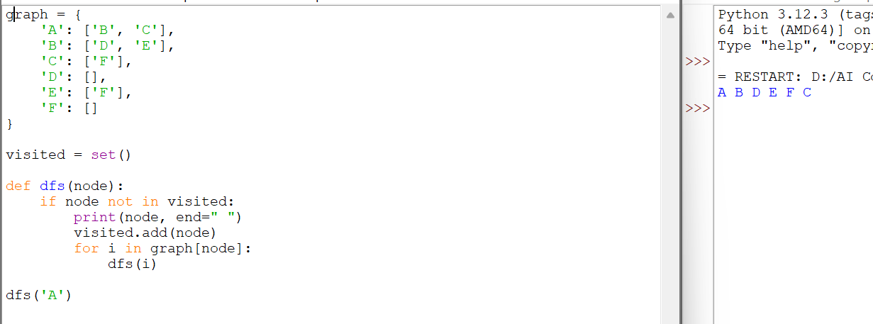

RESULT:
The Python program successfully implemented the Depth-First Search (DFS) algorithm and traversed the graph by exploring each branch completely before backtracking.

